|  |  |  |
| --- | --- | --- |
| Mata Kuliah | **:** | Manajemen Proyek |
| Program Studi | **:** | D4 – Teknik Informatika |
| Semester | **:** | 3 |
| Kelas | **:** | TI – 2D |
| Kelompok | **:** | 5 |
| Nama Anggota | **:** | Bisma Adhiaksa / 244107020216 Ilham Dharma Atmaja / 244107020220 Rafi Adrian Prasetya / 244107020026  Singgih Wahyu Permana / 244107020102  Siti Mutmainah / 244107020143 |
| Tugas Pertemuan | **:** | 7 |

Mockup – Aplikasi Web “Smart Attendance”

* Tampilan Login

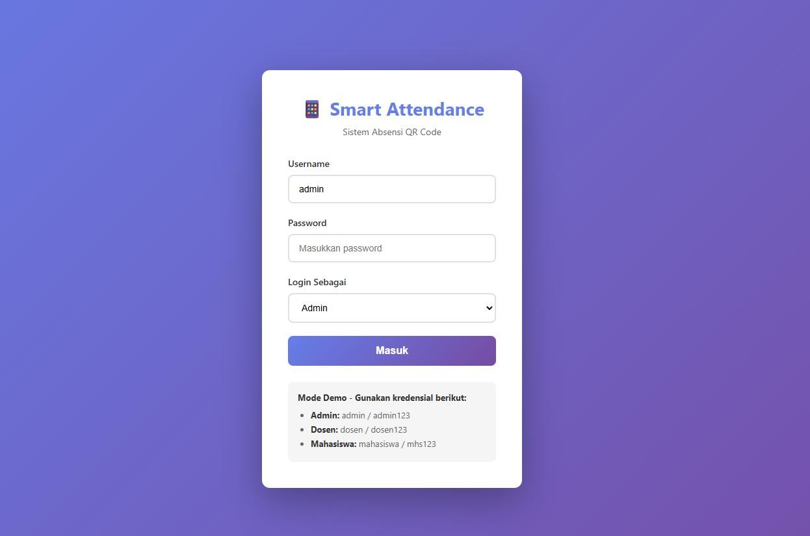

* Dashboard
  1. Dashboard Admin

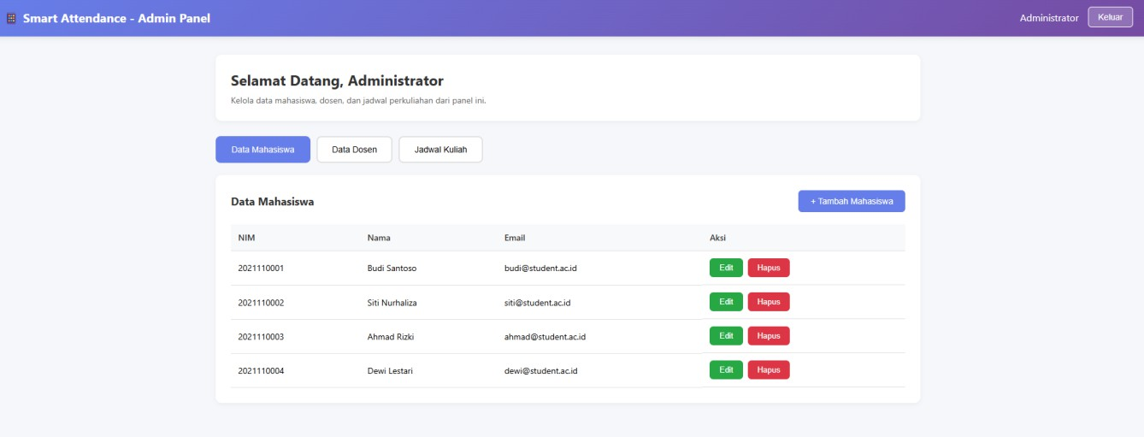

* 1. Dashboard Mahasiswa

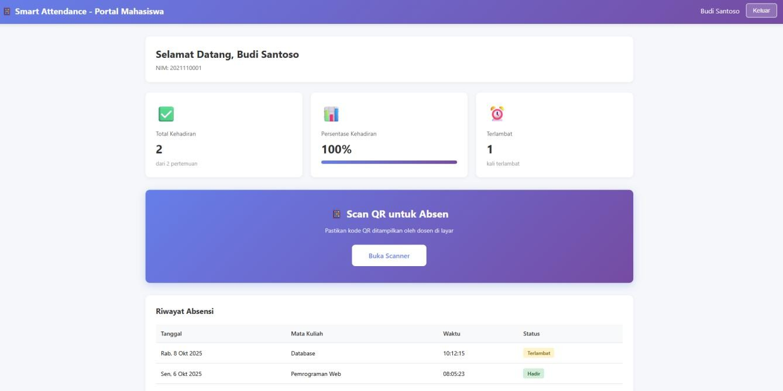

* 1. Dashboard Dosen

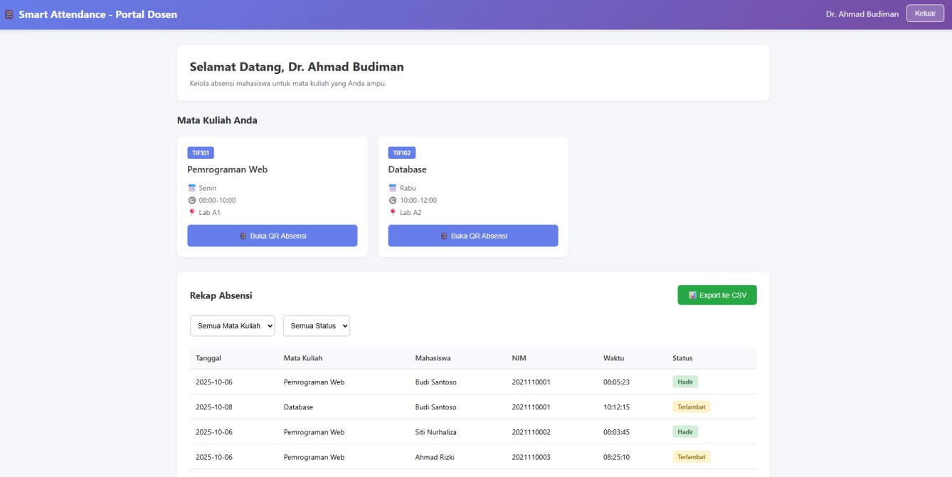

* Halaman QR Code

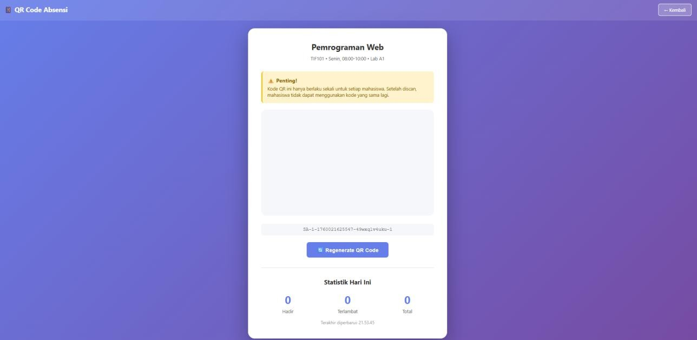

* Halaman Scan QR Code

